EXP NO 5: CREATE A SIMPLE CLOUD SOFTWARE APPLICATION FOR
LIBRARY BOOK RESERVATION SYSTEM FOR SIMATS LIBRARY USING ANY CLOUD SERVICE PROVIDER TO DEMONSTRATE SAAS

AIM:
To Create a simple cloud software application for Library book reservation system for
SIMATS library using any Cloud Service Provider to demonstrate SaaS
PROCEDURE:
step1: Go to zoho.com.
step 2: Log into the zoho.com.
step 3: Select one application step.
step4: Enter application name as library book reservation system.
step 5: Created new application as library book reservation system.
step 6: Select one form
step 7: The software has been created.

STEP1: GOTO ZOHO.COM
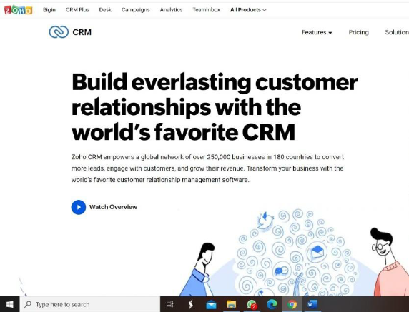

STEP 2: LOGIN TO THE ZOHO.COM
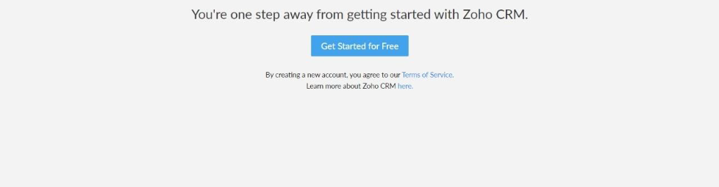
STEP 3: SELECT ONE APPLICATION
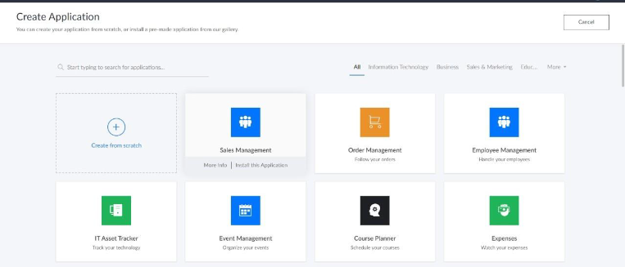
STEP 4: ENTER APPLICATION NAME
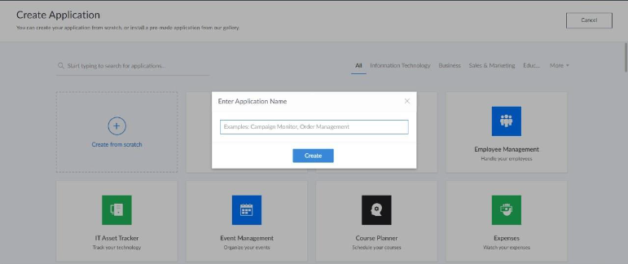

STEP 5: CREATED NEW APPLICATION
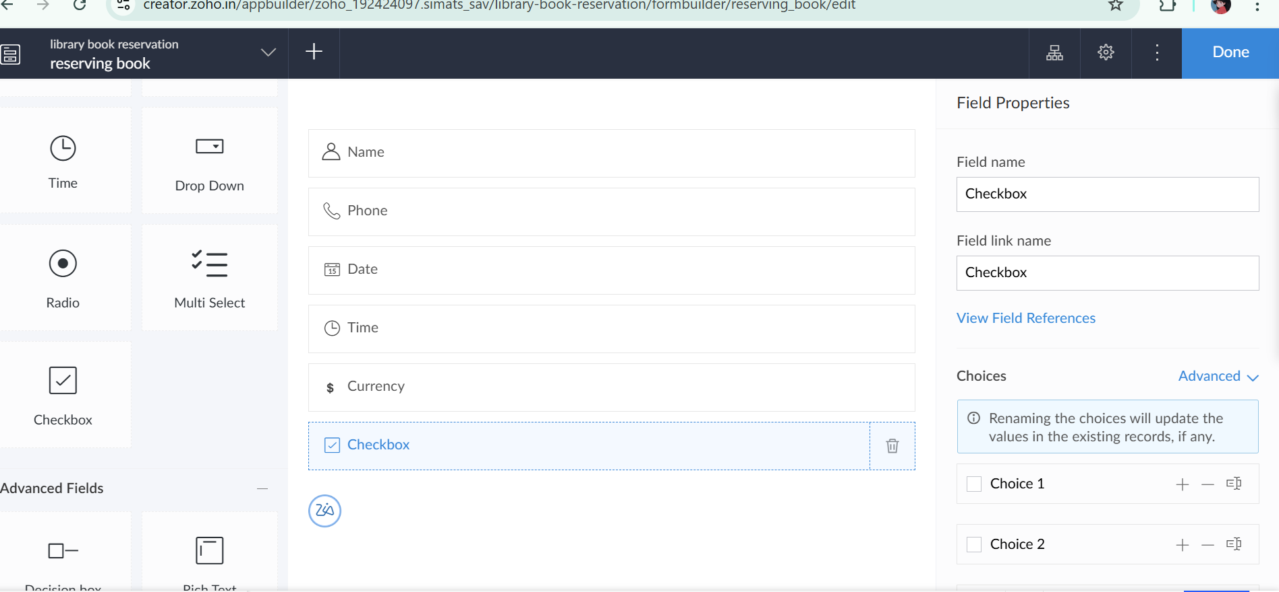
STEP 6: SELECT ONE FORM
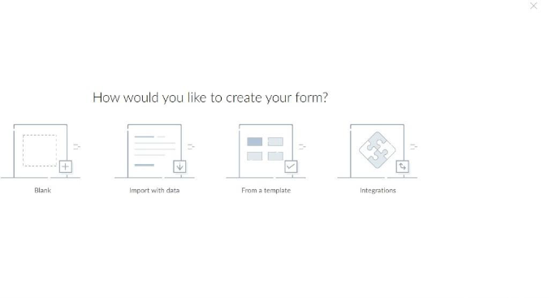
STEP 7: THE SOFTWARE HASE BEEN CREATED.
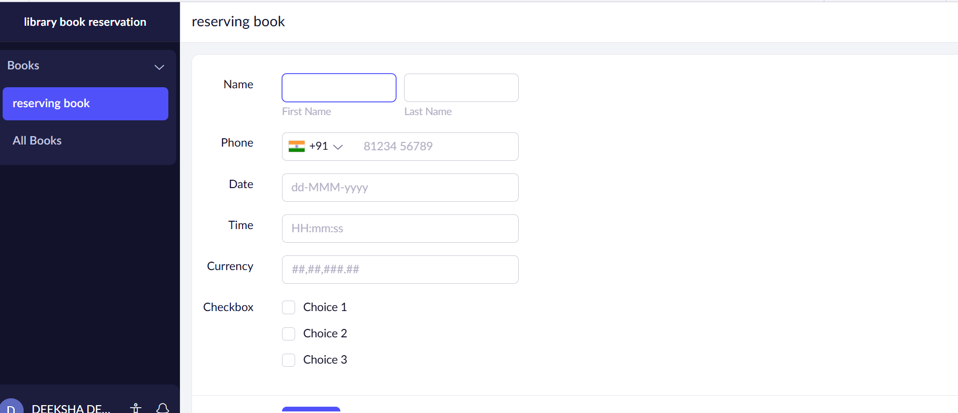
STEP 8:Records Has Been Recorded
